WEB API 06 -KAFKA
Kafka Integration with C#
Objective
To install and configure Apache Kafka on Windows, create a Kafka topic, exchange messages using Kafka Producer and Consumer, and verify successful message streaming.
Implementation Steps
Step 1: Java Installation Verification
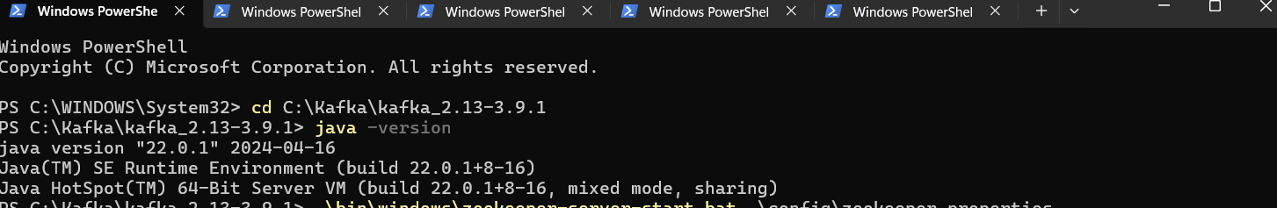
Verified that Java was successfully installed and configured by checking the installed Java version.
Step 2: Kafka Extraction
Extracted the Apache Kafka package to the local system for installation and configuration
Step 3: ZooKeeper Server Initialization
Started the ZooKeeper server using the configuration file. ZooKeeper coordinates and manages Kafka broker services.
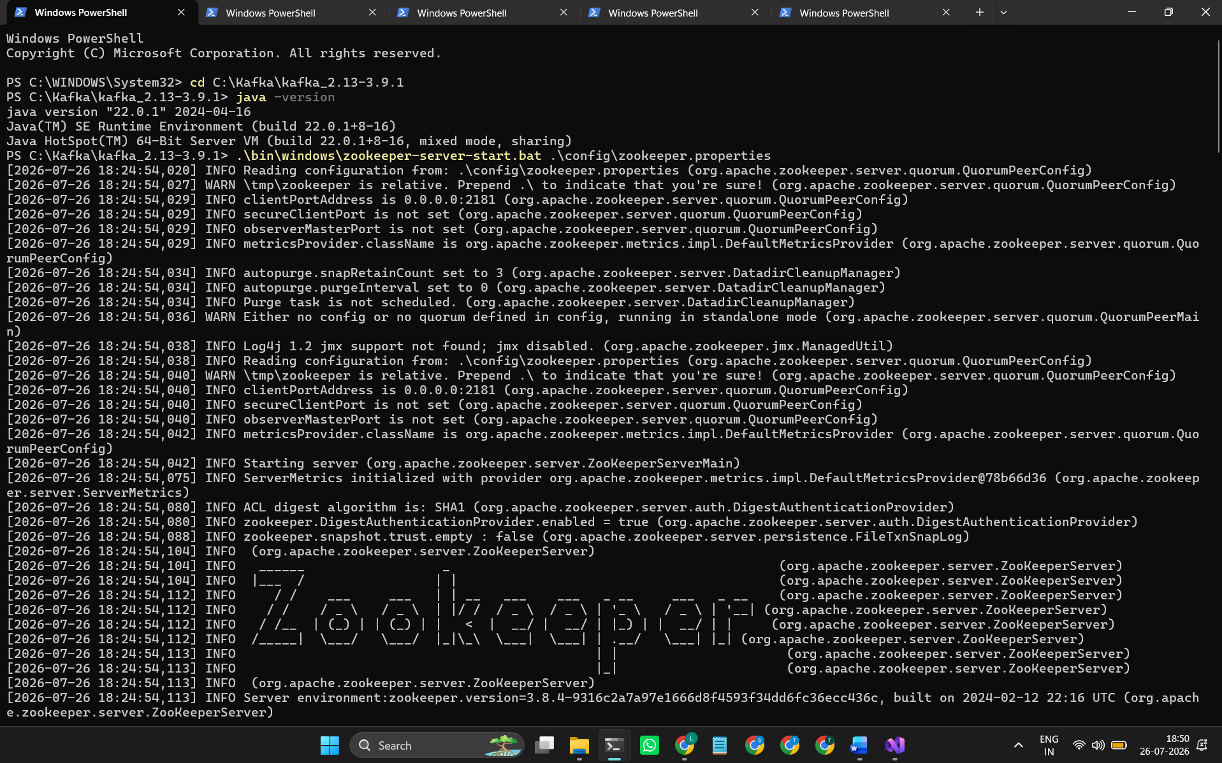
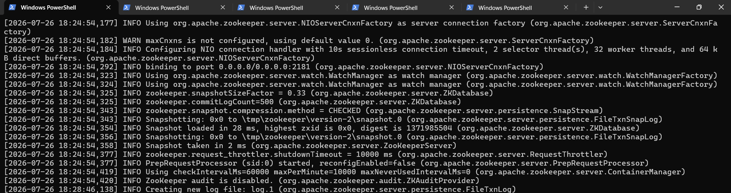
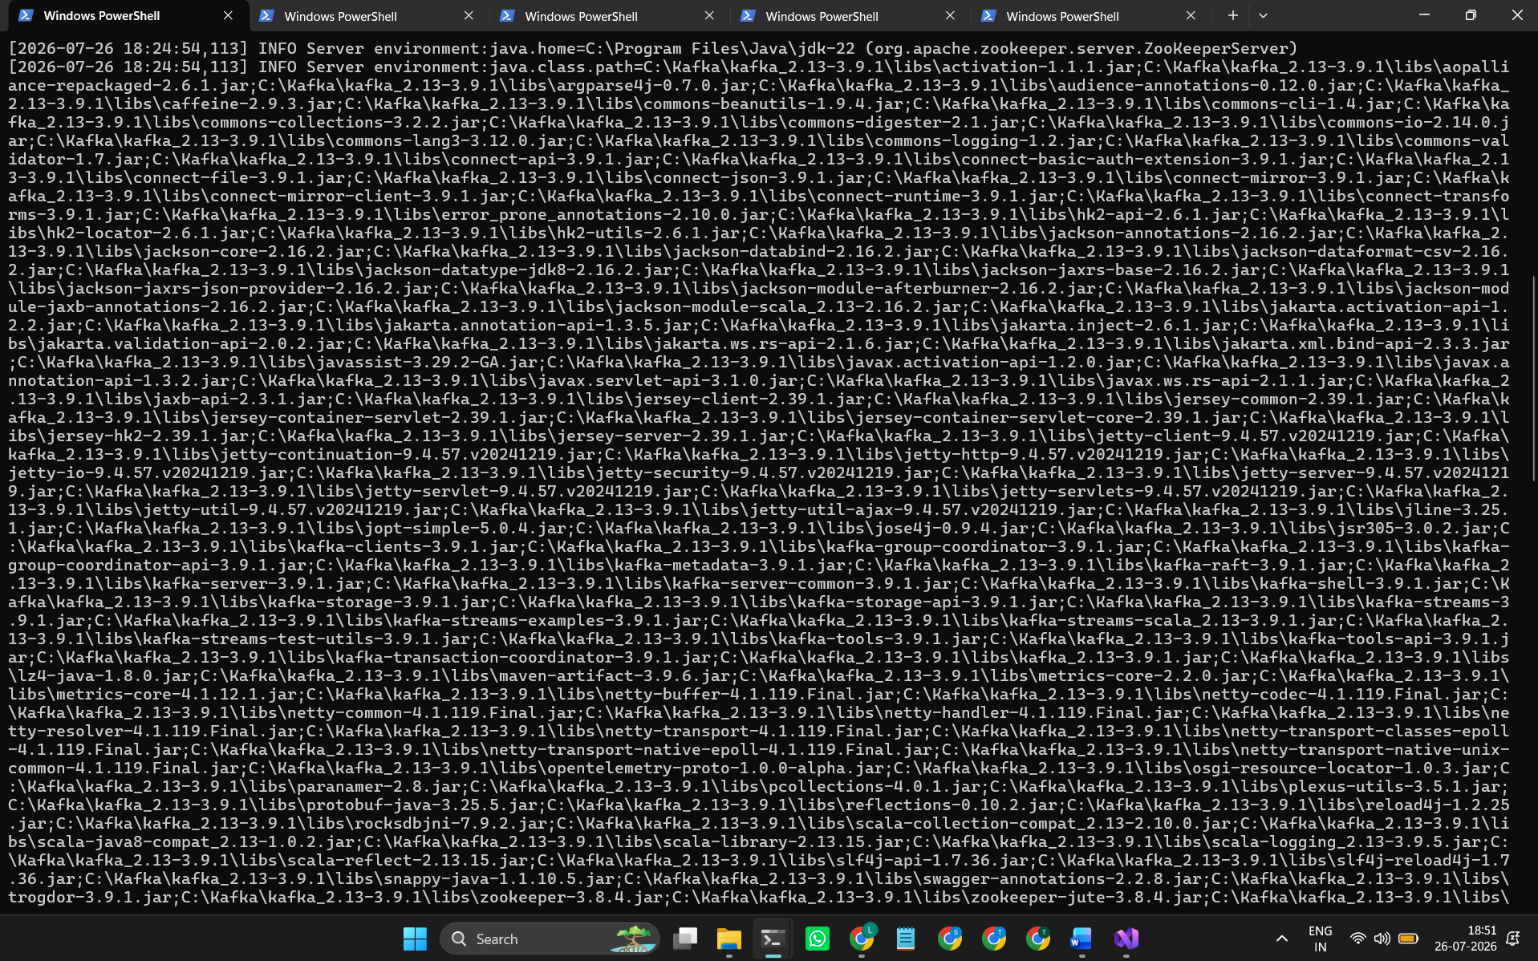
Step 4: Kafka Broker Initialization
Started the Kafka broker to enable message publishing and consumption.

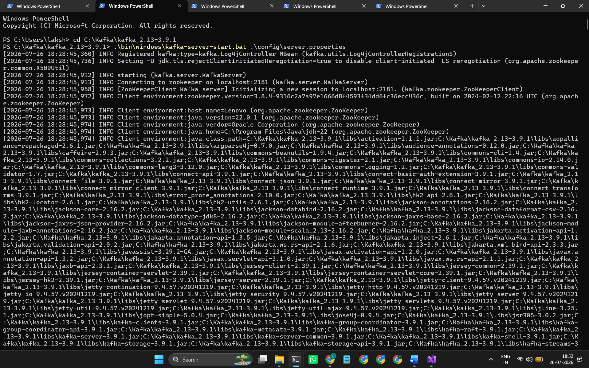
Step 5: Kafka Topic Creation &Topic Verification
Created a Kafka topic named KafkaExecution for publishing and consuming messages and also verified it.
Step 7: Kafka Producer Execution
Started the Kafka Producer and published sample messages to the KafkaExecution topic.
using Confluent.Kafka;
var config = new ProducerConfig
{
BootstrapServers = "localhost:9092"
};
using var producer = new ProducerBuilder<Null, string>(config).Build();
Console.WriteLine("Kafka Producer Started");
Console.WriteLine("Type messages. Enter 'exit' to stop.");
while (true)
{
Console.Write("Message: ");
string? message = Console.ReadLine();
if (message?.ToLower() == "exit")
break
await producer.ProduceAsync(
"KafkaExecution",
new Message<Null, string>
{
Value = message
});
Console.WriteLine("Message Sent");
}
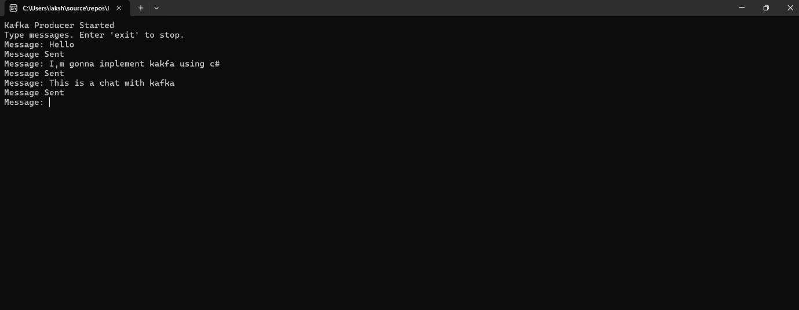
Output:

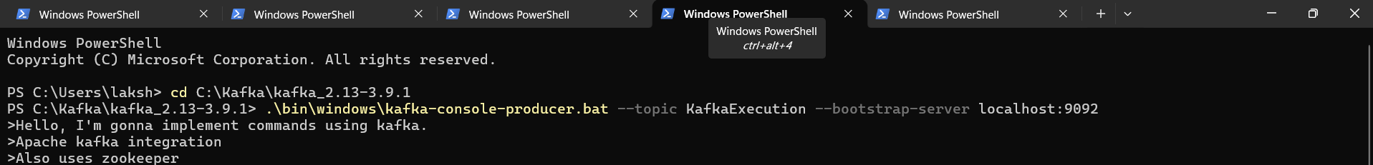
(With built in )
Step 8: Kafka Consumer Execution
Started the Kafka Consumer to receive and display the published messages from the Kafka topic.
using Confluent.Kafka;
var config = new ConsumerConfig
{
BootstrapServers = "localhost:9092",
GroupId = "chat-group",
AutoOffsetReset = AutoOffsetReset.Earliest
};
using var consumer = new ConsumerBuilder<Ignore, string>(config).Build();
consumer.Subscribe("KafkaExecution");
Console.WriteLine("Kafka Consumer Started");
while (true)
{
var result = consumer.Consume();
Console.WriteLine($"Received : {result.Message.Value}");
}
(With built in and with code)
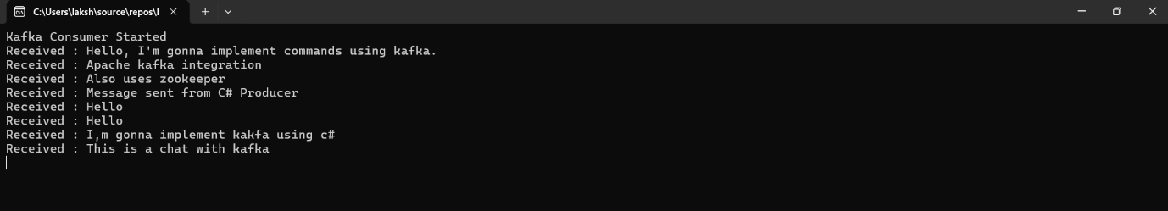
2. Designing the Kafka Chat Application User Interface
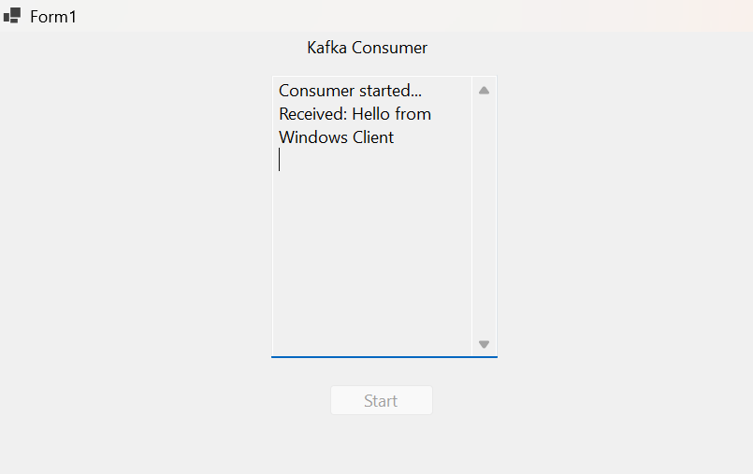

Result
Apache Kafka was successfully installed and configured. ZooKeeper and Kafka Broker were executed successfully. A Kafka topic was created, and messages were successfully published using the Producer and received through the Consumer, demonstrating successful message streaming.

